Small Group Questions:
The Politics of Jesus: How the Gospel of Jesus Challenges our Borders and Blesses our Enemies (Luke 4:14-30)

1. Icebreaker: Do you agree or disagree with the message below? Why or why not?

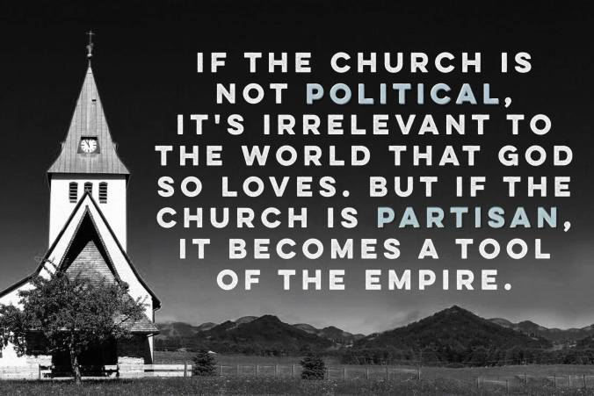

2. What was Jesus’ purpose for reading Isaiah 61:1,2 and giving the commentary he gave? What did the Isaiah text reveal about Jesus’ agenda or mission?

3. What did Jesus mean when he said, “Surely you will quote this proverb to me, “Physician, heal yourself!”

4. In what way did Prophet Jesus put his finger on Nazareth’s core idolatry? How did the Elijah/Elisha illustrations affect the Nazarenes? Why were they so upset?

5. How does the politics of Jesus confront our own politics?

