**October 27, 2019**

**Presence or Promised Land?   (When the Cloud is between us and where we want to go)**

Exodus 13:17-22; 33:7-11; 40:33-38

1. **Read texts.**
2. In what way do the events of the first Passover and arrival of “the cloud” provide a type or foreshadowing of NT events?
3. What was the benefit of having the cloud by day and fire by night?  What did God actually provide through the cloud?
4. Why didn’t God just bring Israel to the Promised Land the way he brought Philip to the Ethiopian?  Miraculously?  What was the point of the cloud in the desert?
5. Does God ever stand between us and our desired goal (Promised Land)?  He could help us arrive sooner and with less stress but he doesn’t.  Instead, he offers…?
6. Review the four NT references to God’s presence dwelling close to us, like the cloud.  Is there one that speaks to you particularly?  Can you think of any other biblical examples?
7. How can a local church develop a culture of anticipating the benefits of living in the cloud?  Is there something we’re presently doing to help foster a greater awareness of God’s presence?  Are there new things we could be doing as a church to foster a greater hunger for God’s manifest presence?  Pray into these things.  Be open to a prophetic message that the Spirit might provide.
8. Thanks for being small group leaders!

BB

**Presence or Promised Land?   (When the Cloud is between us and where we want to go)**

Exodus 13:17-22; 33:7-11; 40:33-38

Shortly after getting married, it became very evident that Myrna and I were different, not just in our gender, but in other ways.  One of us really liked to plan; the other more spontaneous.  One of us thrived with order; the other liked to “go with the flow”.  One of us felt more secure with a GPS (maps); the other was content to rely on instinct, “Let’s just get in the car and drive…we’ll find it.”  These differences brought potential for complementarity…and conflict.  Hold that thought.

Press rewind, about 3 or 4 thousand year ago.  The young nation of Israel has just experienced the Exodus.  The Passover lamb had been sacrificed, the blood applied to their homes, the meal of unleavened bread eaten in haste, and the clandestine escape towards the Red Sea.  Here’s what I want us to sea from our text:  following the Passover event comes the Pentecost event.  Following the sacrifice of the spotless lamb comes the arrival of the pillar of cloud by day and fire by night.  God’s people now possess a manifestation of his presence that they didn’t have before.  The cloud is identified and “the angel of the Lord”, and Yahweh Himself.  The cloud and the people are now always seen together.  The cloud provides protection, guidance, and presence.  The people of God only move when the cloud moves.

“This is great!” you say.  “Aren’t they lucky!”  Yes, they are lucky.  But they’re still stuck in the desert with little water, food, and shelter.  They’ll have to trust God for these most basic needs.  They do have the hope of “the promised land”, but… they are a large group of people with Middle Eastern temperaments, some who like to go with the flow while others are complete control freaks…A`types who love to plan and strategize.  Their MO is “Let’s Go!”  Their favourite book is 7 Habits of Highly Effective People!  Some of these people are like Brian, and some of these people are like Myrna.  And poor Moses has to deal with this unmanageable group and at times wonders why he ever said “yes” to God.

One thing is crystal clear, everybody wants to get to the Promised Land.  The Desert was not their home.  On a bad day, some of the people said, “Let’s go back to Egypt!  We really like the shawarmas there, and the weather.  We actually like everything about Egypt except the Egyptians.”  Others said, “No, let’s get to Canaan!  We’re almost there.”  Some were sent as spies and returned with mixed reviews.  Two said, “It’s awesome!  Let’s go!”  Ten said, “It’s scary!  Let’s freak out!”  Freak out they did…for how many years?  Yep…40 years.  And during those 40 years, there was a lot of complaining.

Here’s the question that begs to be asked, “Why didn’t God make the journey to the Promised Land easier?  Why didn’t he do for Israel what he did for Philip when He astral projected him from Samaria to the desert?  Like “Beam me up, Scottie”.  Whey didn’t God provide a star like he did for the Magi?  You know, “just follow the star that will lead you to Canaan, and we’ll get there in a couple of weeks.”  What if getting to their final destination wasn’t really the point?  What if God’s Presence, the cloud, was the point?  You know, “I want to you know me, to see me, to see how I work, to trust me, to obey me, to enjoy me.  I want you to learn the daily rhythm of complete dependence on my presence.

Is this not like our daily journey of faith?  What’s clear is that the cloud is smack dab in between us and where we want to go?  Israel is here.  The Promised Land is over there.  And where’s God?  Right in between.  “Excuse me God, but would you mind moving a couple blocks to the left, no offence, so that we can get a clear view of where we’re going?”  In other words, would you mind getting out of the way so that we can make some progress?

We really want the destination.  But do we want God?  “I just want my life to settle down; I just want my kid’s to grow up; I just want to be financially secure;  I just want to find my dream guy…”  And God is saying,  “Excuse me… but, I’m here!”

Remember the old Sunday School depictions of the cloud?  They looked something like this.  And this might be exactly what the cloud looked like.  But some suggest that at times, the could looked like this.  The cloud was upon them.  They were surrounded, immersed, shrouded by the cloud.  This was certainly the case in the tabernacle and temple.  The priests couldn’t even perform their duties.  Do you remember the story of the transfiguration of Jesus?  Suddenly, the cloud of God’s presence appeared, “While they were speaking, a cloud appeared and enveloped them, and they were afraid as they entered the cloud.  A voice came from the cloud, saying, ‘This is my son, whom I have chosen; listen to him.”  Did you see that?  The purpose of being enveloped in a fog, where we can’t see what’s in front of us, is so that we can become better atoned to God’s voice and the centrality of Jesus.

So the next time you find yourself in a complete fog, where you can’t see the horizon, where you’re afraid, just stop and breathe deeply.  “For God is not far from each one of us, for in him we live and move and have our being.”  The point of the wilderness is to learn to foster the reality of God’s presence in our lives.

One more thing before we get practical, when the cloud lifts and moves, the people follow.  Sometimes God’s leading is fast.  We ask for direction and in the same day, we receive revelation.  At other times, the cloud stays in one place for a long time.  We don’t have what we think is forward movement, but we have God.  Here’s the lesson:  **When the cloud is not moving, is doesn’t mean that God is not working**.

   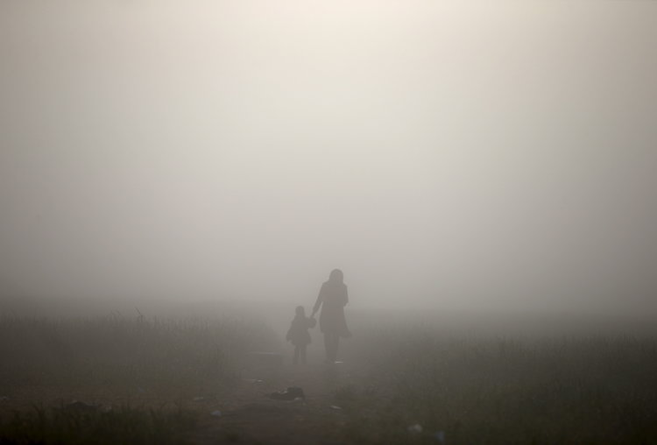

Four NT practices that help us to foster the awareness of God’s presence:  four times where God’s presence is uniquely identified with something we do:

1. **Mission/Evangelism/Discipleship:**  Matthew 28:18-20 – “Go and make disciples…and I am with you always…”
2. **Intentional Community in Worship:**  Matthew 18:20 – “Where two or three are gathered together in my name, I am there in the midst.”
3. **Practising Prophecy:** 1 Corinthians 14:24,25 - **24**But if an unbeliever or an inquirer comes in while everyone is prophesying, they are convicted of sin and are brought under judgment by all, **25**as the secrets of their hearts are laid bare. So they will fall down and worship God, exclaiming, “God is really among you!”
4. **Practicing Gentleness:  ”**Let your gentleness be evident to all. The Lord is near.”  Think about this:  when we’re in a stressful situation where it would be so easy to strong arm, or to dominate, or be inordinately aggressive and intimidating, the choice to be gentle serves notice to everyone in the room that the Lord is near.  He’s present.  He’s in charge.  Therefore, I don’t need to force my way, or his way.

And is there yet another way that we can touch the presence of Jesus in our midst?

“Eat this.  This is my body.  Touch this, smell this, see this, taste this.”

“Drink this.  This is my blood.  Touch this, smell this, see this, taste this.”